Library concerned: Birmingham Women’s and Children’s Library and Knowledge Service
Name of case study: Does suction of saline in ventilated newborn infants cause (or prevent) barotrauma, lung injury or hypoxia?
Date of interview: 15th March 2019

Interviewee | Name: (wished to remain anonymous if used for blog etc)  Job Title: Neonatal Unit Sister  Trust/Employing body: Birmingham Women’s and Children’s NHS Foundation Trust  Email:  Tel:
Interviewee | Please note: you should only provide interviewee details here if consent  to share on the national blog has been obtained
Summary of problem or reason for enquiry | It was suspected that long term use of endotracheal tubes (ETT) may be leading to an increase in ventilator associated pneumonia (VAP). The practice of using saline to “flush” ETT in patients on the neonatal intensive care unit was suspected of being a factor that increased risk. Evidence sought to confirm or disclaim this suspicion.
Brief description of the information found / service provided | A literature search of all the medical and nursing databases was carried out by the library service; abstracts of journal articles identified by the search were downloaded and sent to the interviewee (August 2017)

Summary of outcome and impact | The evidence identified by the search confirming the potential for increased incidence of harm was presented to the NNU intensive care team and used to inform the creation of a plan of care for prevention of VAP in ventilated newborn babies
Immediate Impact  (including quotes) | Unit staff educated in the risks of ventilator associated pneumonias and beneficial techniques being implemented.  In March 2019 The plan of care was introduced providing guidance for staff on the NNU. The practice of using saline to suction ETT has been stopped. The positioning of the ETT has been changed to allow humidification to drain away not into the baby’s lungs.  Extra information on the inline position of the ETT was documented on the ITU chart (This information was not previously recorded)  “The plan brought together all the different elements (of care) into a single unique care package for the first time”  The VAP care plan* was presented by the unit registrar as a poster titled “Reducing ventilator associated pneumonias in a neonatal intensive care unit – a quality improvement project” and included in the abstracts for the International forum on quality and safety in healthcare, 27-29 March 2019, Glasgow SEC Centre, Scotland (Hindley et-al page 336)  https://internationalforum.bmj.com/glasgow/wp-content/uploads/sites/6/2019/03/International-Forum-Glasgow-2019-Conference-Proceedings-FINAL-Google-Docs.pdf  *(referred to here as a care bundle)  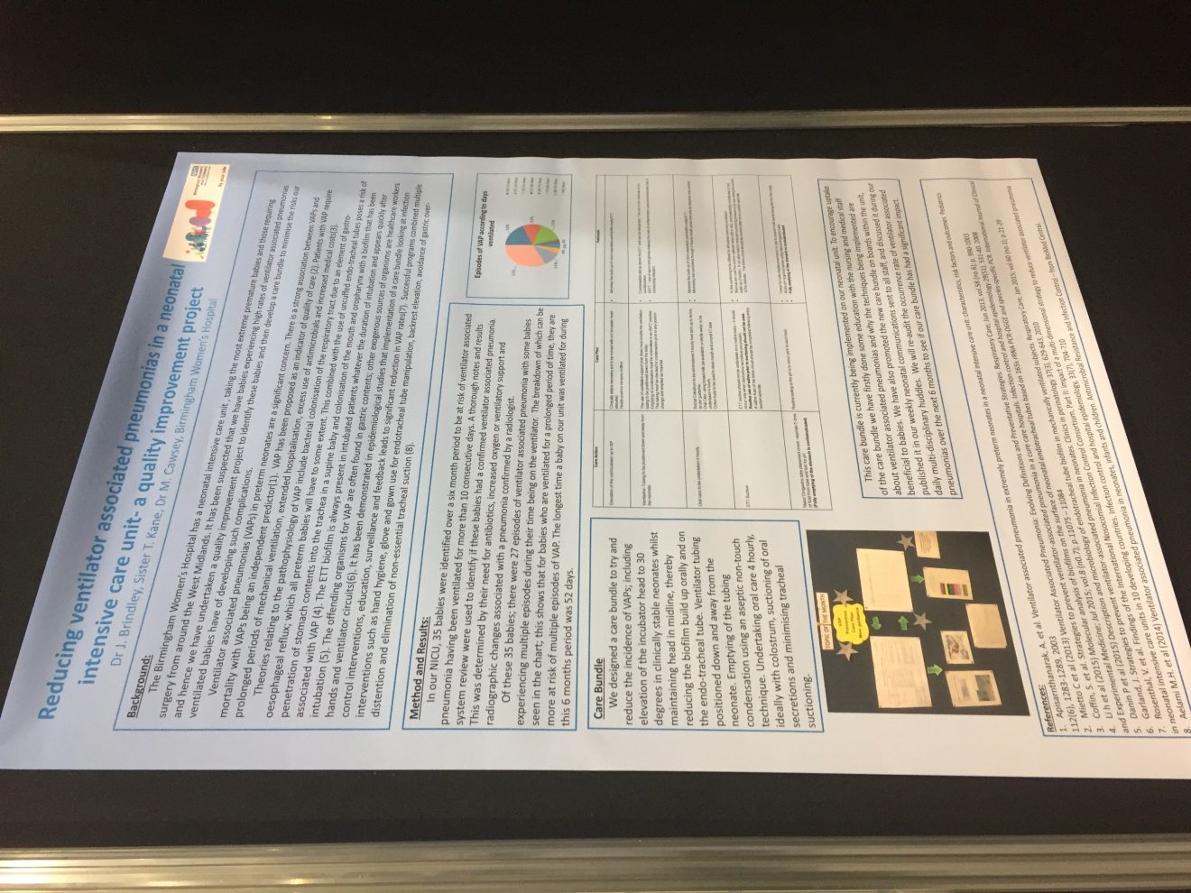
Probable future Impact  (including quotes) | VAP rates to be audited over coming 6 months and reviewed to assess the significance of impact.  Care plan will hopefully be rolled out across the neonatal care network.

